Today is the 3rd Sunday of Lent.
Our gradual return to corporate public worship begins today with a single service at Plaxtol at 11am.
Collect:
Eternal God,
give us insight
to discern your will for us,
to give up what harms us,
and to seek the perfection we are promised
in Jesus Christ our Lord. Amen

The Lenten Collect:
Almighty and everlasting God,
you hate nothing that you have made
and forgive the sins of all those who are penitent:
create and make in us new and contrite hearts
that we, worthily lamenting our sins
and acknowledging our wretchedness,
may receive from you, the God of all mercy,
perfect remission and forgiveness;
through Jesus Christ your Son our Lord,
who is alive and reigns with you,
in the unity of the Holy Spirit,
one God, now and for ever. Amen.

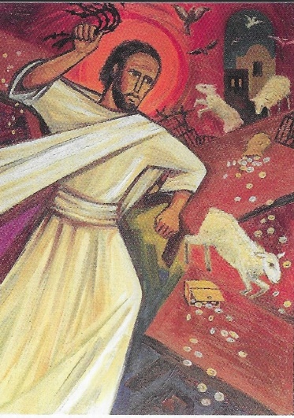
Gospel: John 2:13-22.
The Passover of the Jews was near, and Jesus went up to Jerusalem. In the temple he found people selling cattle, sheep, and doves, and the money changers seated at their tables. Making a whip of cords, he drove all of them out of the temple, both the sheep and the cattle. He also poured out the coins of the money changers and overturned their tables. He told those who were selling the doves, ‘Take these things out of here! Stop making my Father’s house a market-place!’ His disciples remembered that it was written, ‘Zeal for your house will consume me.’ The Jews then said to him, ‘What sign can you show us for doing this?’ Jesus answered them, ‘Destroy this temple, and in three days I will raise it up.’ The Jews then said, ‘This temple has been under construction for forty-six years, and will you raise it up in three days?’ But he was speaking of the temple of his body. After he was raised from the dead, his disciples remembered that he had said this; and they believed the scripture and the word that Jesus had spoken.

Making meaning:
In Matthew, Mark and Luke, the cleansing of the temple comes, near the end, during the last week of Jesus’ life. In John it comes right near the beginning. Why so? John uses the story more symbolically, and as part of pattern that he sets at the heart of his telling of the Good News. The Passover is a key Jewish festival, a remembrance of how God freed them from slavery in Egypt and led them to the promised land. It is an Old Testament narrative of salvation. John sets the story of the adult life of Jesus between three Passovers. Our Gospel reading today is the first, and Jesus is in the temple, preparing it for the new Passover. In the second, Jesus is not in Jerusalem but feeding 5000 and teaching about the new Passover, signified in bread and wine, his body and blood (Ch 6).
In the third, Jesus is back in Jerusalem becoming the new Passover, the Lamb of God who takes away the sin of the world. And so, this important passage can be part of our preparation for Holy Week and Easter. What do we need to do to be prepared to participate in the new covenant of God’s love through the full, final sacrifice of Jesus?
Foodbank News
Our friends at All Saints’, Chatham have been in touch to say that there is considerable increased need at the present time. There is, once again, difficulty handling gifts of provisions, so they are commending on-line giving in either of two ways:
1) You can purchase items for the Medway Foodbank’s ‘need list’ held at www.spareable.co.uk or
2) By donating at medway.foodbank.org.uk/give-help.
Lent Book and Zoom Book-Club event
Many of you are enjoying our Lent book:
Phoebe: a story by Paula Gooder. As promised, a Zoom 'Book-Club' event is planned for after Easter; expressions of interest should be forwarded to Joan (810955 or athomewithjoan@googlemail.com) or Marius (mcmarius@gmail.com).

