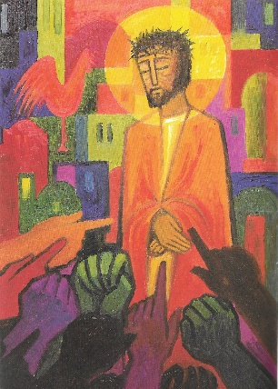
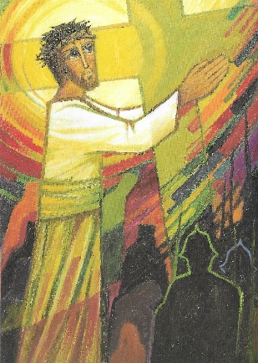
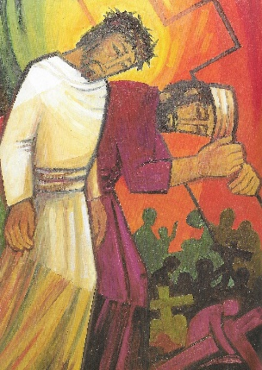
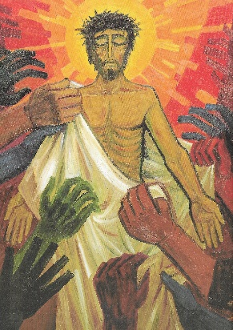
Stations of the Cross
1.
Jesus is condemned to death
Matthew 27: 26-28

God, in Christ, suffers the corrupt justice of a kangaroo court

Lord, help us to see and understand; teach us who you are,
and by your cross and passion liberate us to love with your love.

2.
Jesus takes up his cross
John 19:17

God, in Christ, carries the heavy burden of human lust for violence

Lord, help us to see and understand; teach us who you are,
and by your cross and passion liberate us to love with your love.

3.
Simon of Cyrene
Matthew 27:32

God, in Christ, is partnered by the efforts of a stranger

Lord, help us to see and understand; teach us who you are,
and by your cross and passion liberate us to love with your love.

4.
The women of Jerusalem
Luke 23:27-31

God, in Christ, is sustained by those who understand suffering

Lord, help us to see and understand; teach us who you are,
and by your cross and passion liberate us to love with your love.

5.
Jesus is stripped
Mark 15:20

God, in Christ, is humiliated by the greed of those around him

Lord, help us to see and understand; teach us who you are,
and by your cross and passion liberate us to love with your love.

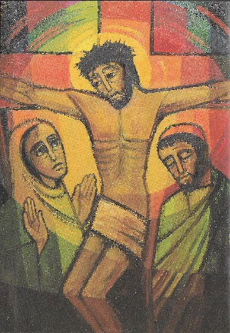

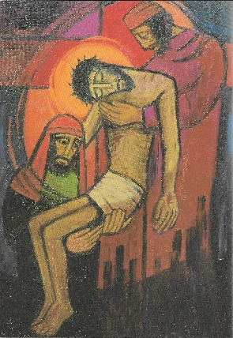

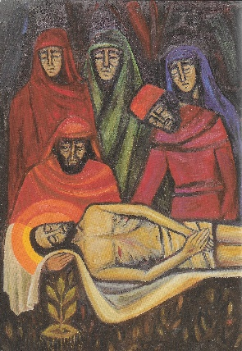
6.
Jesus is crucified
Luke 23:33-34

God, in Christ, is pinned down to die in pain

Lord, help us to see and understand; teach us who you are,
and by your cross and passion liberate us to love with your love.

7.
Mary and John
John 19:26-27

God, in Christ, is committed to community, despite pain and death

Lord, help us to see and understand; teach us who you are,
and by your cross and passion liberate us to love with your love.

8.
Jesus Dies on the cross
John 19:28-30

God, in Christ, embraces the human condition… mortality

Lord, help us to see and understand; teach us who you are,
and by your cross and passion liberate us to love with your love.

9.
Jesus’ body is taken down from the cross
John 19:38

God, in Christ, has his mortality embraced by others

Lord, help us to see and understand; teach us who you are,
and by your cross and passion liberate us to love with your love.

10.
Jesus’ body is placed in the tomb
John 19:39-42

God, in Christ, hallows the grave- transforming it.

Lord, help us to see and understand; teach us who you are,
and by your cross and passion liberate us to love with your love.

